**GUI Steps to output Texture Packs from TexturePacker**

Set TexturePacker to output **Libgdx**

Use these settings (and press the Scaling variants cog and set to None)

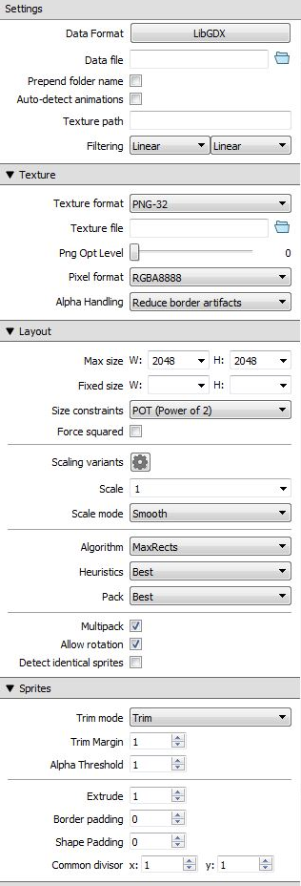

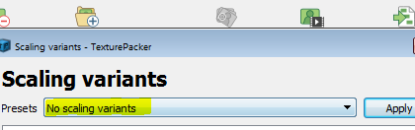

In the example I sent [Model Name] = 14-008_Mechi

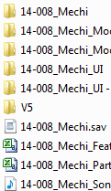

In TexturePacker under Settings in “DataFile” use these names for these images and press Publish:

For HD, Pack0 images -> from ..\V5\PACKSOURCE\HD\Frame0

..\Output\HD\libgdx\[Model Name]_Pack0.atlas

..\Output\HD\libgdx\[Model Name]_Pack0-n (for images)

For HD, Pack1 images -> from ..\V5\PACKSOURCE\HD\Frame1

..\Output\HD\libgdx\[Model Name]_Pack1.atlas

..\Output\HD\libgdx\[Model Name]_Pack1-n (for images)

For SD, Pack0 images -> from ..\V5\PACKSOURCE\SD\Frame0

..\Output\SD\libgdx\[Model Name]_Pack0.atlas

..\Output\SD\libgdx\[Model Name]_Pack0-n (for images)

For SD, Pack1 images -> from ..\V5\PACKSOURCE\SD\Frame1

..\Output\SD\libgdx\[Model Name]_Pack1.atlas

..\Output\SD\libgdx\[Model Name]_Pack1-n (for images)

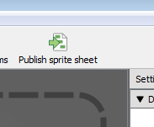

Set TexturePacker to output **SwiftKit (Swift)**

Use these settings (and press the Scaling variants cog and set to None)

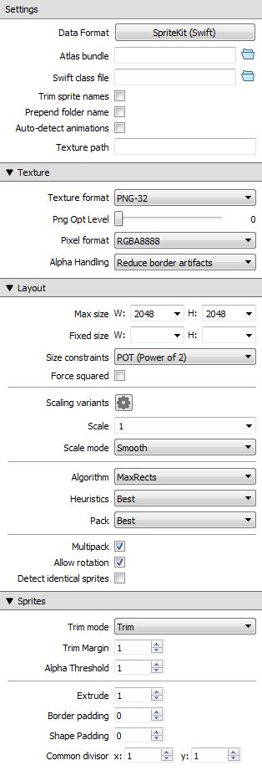



This will generate folders and the image/data files will be inside:

For HD, Pack0 images -> from ..\V5\PACKSOURCE\HD\Frame0

..\Output\HD\SwiftKit\[Model Name]_Pack0.atlasc

For HD, Pack1 images -> from ..\V5\PACKSOURCE\HD\Frame1

..\Output\HD\SwiftKit\[Model Name]_Pack1.atlasc

For SD, Pack0 images -> from ..\V5\PACKSOURCE\SD\Frame0

..\Output\SD\SwiftKit\[Model Name]_Pack0.atlasc

For SD, Pack1 images -> from ..\V5\PACKSOURCE\SD\Frame1

..\Output\SD\SwiftKit\[Model Name]_Pack1.atlasc

For HD, Pack0 images from ..\V5\PACKSOURCE\HD\Frame0

..\Output\HD\libgdx\[Model Name]_Pack0.atlas

..\Output\HD\libgdx\[Model Name]_Pack0-n (for images)

For HD, Pack1 images from ..\V5\PACKSOURCE\HD\Frame1

..\Output\HD\libgdx\[Model Name]_Pack1.atlas

..\Output\HD\libgdx\[Model Name]_Pack1-n (for images)

For SD, Pack0 images from ..\V5\PACKSOURCE\SD\Frame0

..\Output\SD\libgdx\[Model Name]_Pack0.atlas

..\Output\SD\libgdx\[Model Name]_Pack0-n (for images)

For SD, Pack1 images from ..\V5\PACKSOURCE\SD\Frame1

..\Output\SD\libgdx\[Model Name]_Pack1.atlas

..\Output\SD\libgdx\[Model Name]_Pack1-n (for images)